Evaluation of the Global Challenges Research Fund: Stage 1b Synthesis report

Synthesis of the evidence on programme processes and progress towards impact in GCRF’s six flagship investments

Authors: Isabel Vogel, Susan Guthrie and Catrin Hepworth

Acknowledgements

The evaluation team would like to thank the Department for Business, Energy and Industrial Strategy (BEIS) staff who have guided, informed and supported Stage 1a of the GCRF evaluation. We would also like to thank GCRF’s Partner Organisations for sharing their time and valuable insights. We would also like to thank all the module teams for conducting the insightful Stage 1a assessments and our partners – Itad, RAND Europe, AFIDEP, Athena Infonomics, NIRAS-LTS and Digital Science – for their valued collaboration.

Disclaimer

The views expressed in this report are those of the evaluators. They do not represent those of the Department for Business, Energy and Industrial Strategy or of any of the individuals and organisations referred to in the report.

‘Itad’ and the tri-colour triangles icon are a registered trademark of ITAD Limited.

Core Team

Project Director: Chris Barnett, Itad

Team Leader: Isabel Vogel, Itad

Project Manager: Catrin Hepworth, Itad

Data and Engagement Lead: Susan Guthrie, RAND Europe

Contributors:

AFIDEP: Salome Wawire

Athena Infonomics: Anupama Ramaswamy

Itad: Nateisha Decruz-Young, Danielle Freed

NIRAS-LTS: Bouchra Atkinson, Valeria Izzi, Diana Mataya, Colleen Sullivan

RAND Europe: Hamish Evans, Joe Francombe, Cagla Stevenson, Mann Virdee

Submitted by Itad

In association with

Logo - Open Government Licence

© Crown copyright 2022

This publication is licensed under the terms of the Open Government Licence v3.0 except where otherwise stated. To view this licence, visit [nationalarchives.gov.uk/doc/open-government-licence/version/3](http://nationalarchives.gov.uk/doc/open-government-licence/version/3/) or write to the Information Policy Team, The National Archives, Kew, London TW9 4DU, or email: [psi@nationalarchives.gsi.gov.uk](mailto:psi@nationalarchives.gsi.gov.uk).

Where we have identified any third-party copyright information you will need to obtain permission from the copyright holders concerned.

Any enquiries regarding this publication should be sent to us at:   
[enquiries@beis.gov.uk](mailto:enquiries@beis.gov.uk)

Contents

Annexes 7

Annex 1: Updated GCRF ToC 7

GCRF Theory of Change update, September 2022 7

Introduction 7

Overview of GCRF 8

Overview of the document 8

GCRF Theory of Change evolution 9

GCRF evaluation modules informing the ToC update 9

Overview of GCRF’s ToC 10

Visualising GCRF’s ToC 11

Strategic and policy context in 2020–22 14

New international development Strategy 2022 15

Covid-19 pandemic impacts 15

Implications for GCRF’s impact potential 16

Rationale behind GCRF and impact – reviewed August 2022 17

*GCRF’s impact* 18

Updated impact statement and impact-level assumptions 19

GCRF research and innovation interventions and outputs, and evidence from Stage 1a 21

Updated intervention-level assumptions 24

Spheres of direct and indirect influence 25

Outputs, research-into-use interventions, innovation development strategies and intermediate outcomes 25

Sphere of indirect influence 26

Replication, amplification and higher-level outcomes 26

**Higher-level** outcomes 28

Evaluation activities to capture evidence on the spheres of direct and indirect influence 32

# Annexes

## Annex 1: Updated GCRF ToC

# GCRF Theory of Change update, September 2022

The Global Challenges Research Fund (GCRF) is a £1.5 billion fund that runs from 2016 to 2025 to support pioneering research and innovation that addresses the challenges faced by developing countries. GCRF forms part of the UK’s Official Development Assistance (ODA) commitment and contributes to the achievement of the UK’s 2015 aid strategy’s goals. This document presents the updated Theory of Change (ToC) for the GCRF programme, drawing on the first two years of evidence from the GCRF evaluation.

## Introduction

A ToC is an explicit theory or conceptual model of how an intervention, such as a fund, programme, strategy or policy, contributes to a sequence of changes over time to finally reach the outcomes and impact intended by the programme implementers.[1] The GCRF ToC maps the high-level pathways between GCRF’s research and innovation activities, and the positive development impacts it seeks to influence. It sets out how GCRF as a whole intends to promote outcomes and impacts on development challenges in low and middle income countries (LIMICs) and make tangible contributions to the achievement of the Sustainable Development Goals (SDGs). Research and innovation influence development outcomes through complex interactions of multiple stakeholders and agencies in varied innovation, policy and practice systems.[2] The ToC aims to acknowledge this complexity by capturing the assumptions that inform the conceptual model.

GCRF’s ToC provides the framework for the GCRF evaluation that gathers evidence to explore different aspects and tests assumptions at each stage. As is normal in evaluation processes, as evidence is gathered on what works or not, and as understanding evolves, the ToC will be periodically revisited and potentially revised. This document captures the second update, based on evidence form the first two years of the evaluation.

### Overview of GCRF

GCRF ensures that UK science takes a leading role in addressing the challenges faced by developing countries while also developing the UK’s ability to deliver cutting-edge research and innovation (R&I) for sustainable development. GCRF is implemented by 17 of the UK’s research and innovation funders, which commission R&I as Partner Organisationss (DPs). The GCRF strategy sets out three objectives to support this impact:[3]

* Promote challenge-led disciplinary and interdisciplinary research, including the participation of researchers who may not previously have considered the applicability of their work to development issues
* Strengthen capacity for research, innovation and knowledge exchange in the UK and developing countries through partnership with excellent UK research and researchers
* Provide an agile response to emergencies where there is an urgent research need.

Through these objectives, GCRF aims to contribute to realising the ambitions of the UK aid strategy and to making practical progress on the global effort to address the United Nations’ sustainable development goals (SDGs).[4] As a secondary objective, GCRF also aims to build the position and role of the UK R&I sector as global leaders in addressing global development challenges. GCRF’s ToC and the ambitions set out in its the strategy provide the overall framing for the evaluation to assess progress.

GCRF’s ToC was designed to be updated as evaluation evidence emerged. This update sees: changes made to the ‘activity to results’ assumptions, reflecting the findings of Stage 1a and Stage 1b; a representation of the new funding trajectory to reflect the closure of the fund in 2025; and the wording of the impact to reflect the more limited ambitions given the funding trajectory.

### Overview of the document

This document sets out the revised ToC, unpacking GCRF’s intended trajectory towards impact. Section 2 shows the updated visualisation of the GCRF ToC and a guide to navigate it. Section 3 reviews the strategic and policy context for GCRF. Sections 4 and 5 review the evidence from Stage 1a and the implications for GCRF’s rationale, the ToC and the assumptions. Section 6 provides an overview of the forthcoming evaluation activities that will track the ToC through the spheres of direct and indirect influence towards the desired impact.

## GCRF Theory of Change evolution

This document presents the updated narrative and diagram of GCRF’s ToC, based on a review of the original ToC led by the evaluation team, which involved discussions and feedback with the GCRF evaluation working group, and a review of the Stage 1a and Stage 1b evidence. The GCRF ToC represents how GCRF as a whole aims to achieve impact and provides the framework for GCRF’s accompanying evaluation. It sets out a formal articulation of the implicit rationale and assumptions that have informed the design and implementation of GCRF. The ToC is intended to be updated and to evolve as evaluation evidence becomes available.

The ToC was originally developed in 2017–18 by a Technical Working Group (TWG), supported by the evaluation contractor, Itad. The TWG made up of representatives from UK Research and Innovation (UKRI), academies, the Higher Education Funding Council for England (HEFCE)/Research England (RE) and UK Space Agency (UKSA), Department for Business, Energy & Industrial Strategy (BEIS) staff and the evaluation team. The original ToC narrative can be read in the Foundation Stage Evaluation Report, 2018, which reflected the assumptions and expected trajectory of the fund at the time.[5]

There was an interim update in March 2022, before the evidence from Stage 1a was available. This is now the second update, led by the evaluation team.

ToC update method

In January–March 2022, the ToC was reviewed and updated in the light of the Stage 1a evidence. The GCRF Evaluation Working Group – EWG (made up of representatives of the same DP organisations that were involved in the original ToC development, as well as some of the same individuals) were consulted on how the GCRF ToC should be updated. Alongside this, the Stage 1a evaluation findings (2020–21) provided insights into the strength of GCRF’s foundations and the implications of these for the ToC ambitions for development impact at scale. In August 2022, once the Stage 1b had become available, the ToC was reviewed again and adjusted to reflect the new evidence.

### GCRF evaluation modules informing the ToC update

The GCRF evaluation tracks and tests the GCRF ToC through a series of modules over five years, from 2020 to 2025. Figure 1 presents an overview of the GCRF evaluation.

Figure 1: GCRF evaluation[6]

In 2020–21 the evaluation completed Stage 1a, which looked at the early stages of the ToC: management processes and the strength of GCRF’s foundations for development impact and the early stages of the ToC.

Stage 1b (the first part of which was completed in 2021–22) looked at GCRF’s six ‘signature investments’ – the flagship programmes and awards that represent about half the spend in the portfolio and are intended to align closely with the GCRF strategy and ToC. This module is still focused on the early part of the ToC in terms of processes, but also examined early results. In addition, a fund-wide survey was conducted that has yielded important insights into processes, outputs and outcomes and into factors which have enabled/constrained these.

The ToC also has to be adjusted to reflect the changes in the UK policy context that have led to reductions in ODA funding in 2021 as a result of the impact of the Covid-19 response on UK Government spending. As an ODA R&I fund, this led to reduced funding for GCRF as well. Subsequently, BEIS has taken the strategic decision to wind down and close GCRF in early 2025. Section 2 discusses this in more detail.

## Overview of GCRF’s ToC

The GCRF ToC aims to map high-level yet plausible pathways between GCRF’s research and technologies and the positive development impacts it seeks to influence.

R&I initiatives influence development outcomes through complex interactions of multiple stakeholders and agencies in varied innovation, policy and practice systems. GCRF’s scope is very large, with an overall investment of £1.5 billion into R&I initiatives spanning numerous policy domains and sectors in low and middle-income countries (LMICs) (e.g. health, education, environment, enterprise, trade, humanitarian assistance and civil society). This adds many additional layers of complexity to the research/innovation-impact system. The ToC aims to acknowledge this complexity while presenting a simplified model to guide DPs, researchers and innovators and the evaluation in monitoring change and progress towards the desired impact.

Represented at the right-hand side of the diagram, GCRF’s original expected impact was:

‘Widespread use and adoption of GCRF-supported research-based solutions and technological innovations enables stakeholders in LMICs to make progress at scale towards addressing complex development challenges. These efforts will contribute to the achievement of the SDGs, enhancing people’s wellbeing, improving equality for people of all genders, promoting social inclusion, economic development and environmental sustainability in developing countries. These improvements will be sustained into the future by enduring equitable research and innovation partnerships between the UK and LMICs, and enhanced capabilities for challenge-oriented research and innovation in all regions.’

In March 2022, GCRF’s stakeholders on the EWG agreed that the overall trajectory and ambition of the ToC should remain the same, while recognising that the potential for development impact has become constrained due to the changes in the policy context (see Section 2.) So, while the shorter-term outcomes have good potential to emerge as anticipated, the medium and longer-term outcomes and ultimate progress towards addressing SDG-level impact may only emerge in limited ways in certain places, sectors and countries. They are unlikely to emerge at scale or create the tangible contributions in LMICs as originally set out in GCRF’s vision and ambition.

This leads to a revised impact statement and assumptions, which are set out in Section 5.

### Visualising GCRF’s ToC

The ToC is structured around different ‘spheres of influence.’ This concept is used by a number of other research-impact ToCs and funders (see Ofir et al., 2016) and was recommended at the original ToC workshop as a helpful conceptual frame. The spheres help to represent the complexity of GCRF’s change processes and the degree of GCRF’s agency to influence change at different scales. Figure 2 shows the updated ToC diagram.

Each sphere represents a progression of interventions and outcomes. GCRF interventions do not simply appear on the left-hand side of the ToC; rather, specific types of strategies and interventions are needed to support outcomes at each stage. For example, initial research and engagement activities need to be followed by specific research-into-use and innovation development strategies at a later stage. Finally, strategies for replicating and scaling innovations and research are required to support impact. These strategies are interlinked, as in the real world many GCRF projects and programmes engage with stakeholders iteratively right from the design stage, e.g. to establish demand and co-identify priorities and entry points. This iterative engagement is represented by two-way feedback loops between strategies in different spheres.

The ToC should be read from left to right – but it does not depict a linear process, and different research projects and programmes will have different starting points. The ToC depicts a progression from activities towards impact. GCRF’s initial R&I interventions are represented on the left of the diagram, followed by the sphere of direct influence, where GCRF projects and programmes work collaboratively with stakeholders in developing countries to translate technologies and research-into-use and directly influence outcomes at a project/programme scale. These first domains represent the ‘innovation systems’ that GCRF aims to stimulate by bringing entities together across disciplinary and geographical boundaries to catalyse research and innovations.

The change process then moves further into the sphere of indirect influence, where change is in the remit of wider stakeholders, but where GCRF actively engages with replication and scaling processes to encourage stakeholders to apply research and innovations, in order to influence further change at different scales in diverse settings, which can be thought of as the outcome systems for GCRF research and innovation. Finally, the diagram depicts GCRF’s impact, where the desired positive impacts will be established for people living in LMICs at scale. However, GCRF’s real-world change process is iterative and non-linear, as represented by various feedback loops in the diagram.

The ToC now shows the funding period for the fund, from 2016 to 2025. Given the strategic decisions on the funding trajectory, this is represented at the bottom of the diagram. The timeline remains as in the original ToC, reflecting a realistic time-to-impact for GCRF’s R&I investments.

Figure 2: GCRF’s ToC

Source: Itad 2022

## Strategic and policy context in 2020–22

When the ToC was first developed, GCRF as a whole was expected to have a measurable aggregate impact on the SDGs over its planned timeline of 15 years, from the initiation of the programme in 2017 to 2032.[7] This impact was considered to be commensurate with the scale funding available to GCRF as a large-scale, £1.5 billion portfolio making R&I investments over two five-year phases.

GCRF’s strategy was developed in 2017, as a high level framework document. It sets out the intended aims and objectives, and a broad investment strategy for R&I investments that are ODA compliant, problem and solution focused, represent research excellence as well interdisciplinarity, are impact-oriented and are underpinned by capacity building and partnership.[8] The original twelve challenge areas are also set out and a number of risks to implementation identified:

* lack of buy-in from the communities that need to be mobilised to realise its ambitions, including researchers and non-academic partners in the UK and in the Global South
* poor coordination between Partner Organisationss, leading to duplication of efforts rather than complementarity
* a lack of active portfolio management, meaning that GCRF funds a series of discrete projects rather than a coherent set of responses to specific challenges
* failures of governance, monitoring, evaluation, reporting and/or communications, meaning that confidence in the ODA compliance, value for money and/or effectiveness of the GCRF as a whole is eroded
* failure to create real impact in developing countries[9]

Mitigations set out to address risks included: international partnerships; demonstrating international best practice through portfolio monitoring, impact assessment and comparator studies; governance through a Strategic Advisory Group and a GCRF Delivery Forum to coordinate Partner Organisations.

GCRF’s strategy has been implemented broadly along these lines, although the evaluation has found that some of the risks have actually come to pass and the mitigations have been insufficient, e.g. poor coordination among Partner Organisationss; lack of active portfolio management has led to a significant degree of incoherence; monitoring, reporting, specifically the tracking of VfM has not become established as a practice across GCRF. The evaluation evidence will be discussed further below.[10]

The first years of GCRF’s evaluation, 2020–22, have seen significant challenges in the strategic, policy and economic context of GCRF. This has brought commensurate constraints to the scale and ambitions of GCRF. Following the three-year Spending Review in September 2021, the decision was made to wind down both of BEIS’s ODA funds, GCRF and Newton, by 2025, with a continuation of commitments for existing awards and programmes but no new commissioning after 2022. The broader strategic changes include: a new policy framework that integrates ODA into defence and foreign policy; a new UK Government Strategy for International Development; and significant budget reductions for 2021–22 as part of the Covid-19 pandemic response. We look at these interrelated factors and the implications for GCRF’s ToC.

### New international development Strategy 2022

A new UK Government Strategy for international development was launched in May 2022,[11] developed in the wake of the Integrated Review of Security, Defence, Development and Foreign Policy, published in March 2021.[12] The 2022 Strategy fits within the broader vision outlined in the Integrated Review. International development priorities form one part of wider UK foreign policy, with a clear focus on defence and security and on the UK’s place within shifting global geopolitics. Both of these policy documents guide the work of the new Foreign, Commonwealth & Development Office (FCDO) – formed in August 2020 by merging the Foreign and Commonwealth Office (FCO) and the Department for International Development (DFID) – and that of all ODA-spending departments, including BEIS, which funds GCRF.

Thematic priorities identified in the 2022 International Development Strategy include: investment for sustainable, green economic growth; education, empowerment and protection from violence for women and girls; humanitarian assistance; and global health, climate and nature – all topics which have been key aspects of GCRF’s R&I. While there is a shift to country and bilateral programmes, the 2022 Strategy retains a focus on using world-class R&I to provide evidence-based development responses, meaning that GCRF remains relevant to the new policy context.

### Covid-19 pandemic impacts

Through 2020–21, the Covid-19 pandemic significantly impacted on GCRF awards, delaying fieldwork, disrupting the production of outputs and research-into use activities. Broader knock-on effects have also been felt at the level of ODA spending and management, with resulting cuts to the GCRF budget in 2021–22. In 2021, in response to the economic recession and as part of resultant fiscal policies, the UK’s ODA commitment was temporarily reduced from 0.7% to 0.5% of gross national income (GNI).[13] This reduction in spending led to cuts to ODA-spending government departments – including BEIS.[14] These sudden budget reductions, which amounted to around 70% of committed spend, affected GCRF’s DPs and investments across the board, with grants being delayed, reprofiled or terminated.[15]

Following the three-year Spending Review in September 2021, the decision was made to wind down both of BEIS’s ODA funds, GCRF and Newton, by 2025. Following this , BEIS’s ODA allocation stabilised and some improvements were seen. Existing GCRF commitments will now be met, with commissioned projects, including the large-scale flagship programmes, supported until March 2025. The cuts to awards that were mid-way through implementation from 2020/21, however, will not be reimbursed, so projects have reduced scope to accommodate net budget reductions.

### Implications for GCRF’s impact potential

The impact of the Covid-19 pandemic fell most heavily on awards that were in their final or mid-term stages. Covid restrictions prevented stakeholder engagement and research-into-use activities in LMICs and other activities to help position awards for impact. The evaluation found that many of these activities have been delayed or been downscaled, with implications for GCRFs impact potential.

Figure 3: GCRF budget allocation 2022–25[16]

The impacts of Covid, the reduction in funding and the phasing out of the fund over the coming three years have led to uncertainty throughout 2021, with significant impacts in terms of GCRF’s partnerships and accomplishments. The uncertainty has proved disruptive to building long-term R&I partnerships and working collaboratively with LMIC-based partners, as well as affecting delivery of planned activities. Effectively, there are only two years of R&I activity remaining, as in the final year programmes will be focused on finalising outputs. Award teams – and, potentially, partnerships – will disband and move on. Therefore, the ToC update reflects these new circumstances, as well as the insights from the Stage 1a and 1b evidence.

## Rationale behind GCRF and impact – reviewed August 2022

This section reviews and updates the original rationale and framing of GCRF’s impact, as set out in the ToC narrative contained in the Foundation Evaluation, 2018.[17]

The overarching rationale for GCRF was that complex development challenges require new kinds of R&I. GCRF was established to respond to a critical need to address urgent and evolving global development challenges through catalysing a new wave of R&I in order to make progress towards the SDGs. The assumption is that new kinds of R&I are needed to tackle development challenges, including work that is interdisciplinary and that mobilises multistakeholder partnerships across the global North and South, and across sectoral boundaries, to build lasting R&I capabilities and infrastructures in LMICs. As a secondary objective, GCRF aims to build the reputation of UK as global leaders in addressing global challenges.

Evaluation evidence

The evaluation has not directly tested these framing assumptions at this point in time, as outcomes and impact in LIMICs cannot yet be observed. However, the emerging evidence suggests that these assumptions are valid, as:

* GCRF is more interdisciplinary than other UKRI investments (data science analysis, 2021)
* multisectoral partnerships and stakeholder networks are being mobilised across countries, sectors and disciplines (fund-wide survey analysis, 2022)
* novel R&I capacities are being catalysed in LMICs and the UK (fund-wide survey analysis, 2022)
* the flagship investments are supporting potentially transformative work (process evaluations, 2022).

### GCRF’s impact

GCRF’s impact is seen to have two aspects: direct and indirect. First, the impact statement highlights how tangible development impacts are achieved through the direct use and adoption of GCRF-supported policy, practice and technology innovations by development stakeholders to make progress at scale on development challenges. This implementation process is dynamic, with new demands for ongoing problem-solving research expressed by stakeholders in LMICs to support implementation. This leads to the second aspect of GCRF’s impact: that GCRF will help establish new capabilities and systems for challenge-oriented, interdisciplinary R&I in both the UK and LMICs, sustained by enduring, equitable R&I partnerships. Tangible progress towards these impacts was originally anticipated to emerge by 2021.

Although there have been some changes in the wider context, GCRF remains an unprecedented investment by the UK Government into research and innovation for development (R4D), perhaps the largest ever UK investment in ODA R&I, and so GCRF’s impact was set by the original TWG at a commensurate scale.

The ToC has always acknowledged that GCRF’s direct influence on outcomes reduces as the ToC moves towards the impact. Nevertheless, a central premise of GCRF is that the fund’s managers and partners should be accountable for ensuring that the conditions for impact and longer-term outcomes are established, so it is still reasonable to expect significant contributions to development outcomes and impact.[18]

However, the delays caused by Covid-19, alongside the ODA funding reductions from 2021 to 2025, may temper the original impact ambitions, and impact may be more diffuse without the anticipated coordination and mobilisation of aggregate GCRF portfolios towards impact that the original ToC expressed. Nevertheless, when consulted in March 2022, GCRF’s representatives from POs felt that the longer-term outcomes may well still emerge but in specific countries, locations or sectors rather than widespread or at scale in LMICs. So it was agreed to retain the longer-term outcomes as represented in the ToC visual (right), but to change the assumptions about the extent and reach of change.

Evaluation evidence

The evidence from Stage 1a and Stage 1b suggests that both aspects of GCRF’s impact still have validity and potential to emerge, even if the fullest funding aspirations were not achieved. Good evidence from both Stage 1a and Stage 1b highlights that the foundations for partnerships, capacities and R&I infrastructure systems are in place, with potential for durability.[19] Stage 1b of the evaluation (focusing on GCRF’s ‘signature investments’) has found that these programmes have transformative potential, and many examples of strong and effective practice show that the portfolio is well positioned to achieve tangible and durable development outcomes envisioned in its strategy and ToC.[20] However, the original ToC anticipated some coordination of portfolios and mobilisation towards impact, through structures such as the Challenge Leaders and impact-oriented activities in the final years of the fund. The evidence from Stage 1b highlights that Challenge Leaders were not fully effective, while the rapid tailing off of GCRF funding will mean that activities to mobilise portfolios will not take place to the level anticipated. There is a risk that GCRF may not reach the aggregate scale, depth and breadth of contributions to the SDGs originally envisioned in the ToC.

### Updated impact statement and impact-level assumptions

We propose that the impact statement should be updated to reflect the current situation. The bolded elements in the original have been changed, together with the assumptions.

|  |  |
| --- | --- |
| ‘Widespread use and adoption of GCRF-supported research-based solutions and technological innovations enables stakeholders in LMICs to make progress at scale towards addressing complex development challenges. These efforts will contribute to the achievement of the SDGs, enhancing people’s wellbeing, improving equality for people of all genders, promoting social inclusion, economic development and environmental sustainability in developing countries. These improvements will be sustained into the future by enduring equitable research and innovation partnerships between the UK and LMICs, and enhanced capabilities for challenge-oriented research and innovation in all regions.’ | ‘Use and adoption of GCRF-supported research-based solutions and technological innovations in specific countries, locations and/or sectors enables stakeholders in LMICs to make progress in their settings towards addressing complex development challenges. These efforts will contribute to the achievement of the SDGs, enhancing people’s wellbeing, improving equality for people of all genders, promoting social inclusion, economic development and environmental sustainability in developing countries. These improvements will be sustained into the future by enduring equitable research and innovation partnerships between the UK and LMICs, in specific countries, contexts and sectors, supporting enhanced capabilities for challenge-oriented research and innovation in all regions.’  Revised impact-level assumptions:   * GCRF-funded R&I will make tangible, measurable contributions to complex development challenges in specific countries, sectors and contexts. * GCRF-funded R&I will catalyse durable multisectoral R&I partnerships, stakeholder networks and novel R&I infrastructures to contribute to development impact and support ongoing and future work (these will represent GCRF’s legacy). * Reduced impact activities in GCRF’s final years, due both to time-lag effects from Covid delays and ODA budget reductions, have limited GCRF’s original scope and vision for impact, so outcomes and impact are anticipated to emerge at a more localised scale and to be more scattered in their effects. |

The original rationale and framing assumptions are set out in Annex 1. These have not been tested through the evaluation at this stage, as there is insufficient outcome evidence as yet; they were developed from the review of literature and stakeholder consultations in 2016. Later modules of the evaluation (from 2023) will investigate the legacies created by GCRF in LMICs and the UK and will explore to what extent these rationale assumptions were borne out.

The ToC narrative now moves to the left-hand side of the diagram, where GCRF’s interventions and outputs are explored.

## GCRF research and innovation interventions and outputs, and evidence from Stage 1a

The ToC begins in the ‘sphere of direct influence’ with a description of GCRF’s initial R&I interventions and outputs. It articulates how GCRF’s challenge-led projects and programmes are expected to lead to outputs. The principal interventions (see Figure 4) being implemented by GCRF are:

* Partnering interventions: including Global Engagement events, brokering R&I partnerships between UK and LMIC institutions
* Capacity building interventions: including fellowships and studentships, and capacity development activities to build R&I skills in LMICs
* Challenge-led, multisectoral R&I interventions, including bi/trilateral DP programmes, interdisciplinary Hubs and Rapid Response Studies
* Stakeholder mobilisation and networking interventions, engaging stakeholders in government, business, research, innovation, civil society and communities
* Empowering Challenge Leaders and champions for uptake, including establishing Challenge Leaders, clustering GCRF projects working on similar issues and geographies within challenge areas and supporting them via aggregated and enhanced research-into-use activities in specific locations
* Support to R&I infrastructures and frameworks, including support to technical systems and hardware and software, market development, policy and regulatory advocacy.

The original ToC proposed that if the assumptions in Figure 4 hold true, and if learning can help to optimise GCRF design and delivery, then combinations of these initial interventions will produce GCRF’s initial outputs as follows:

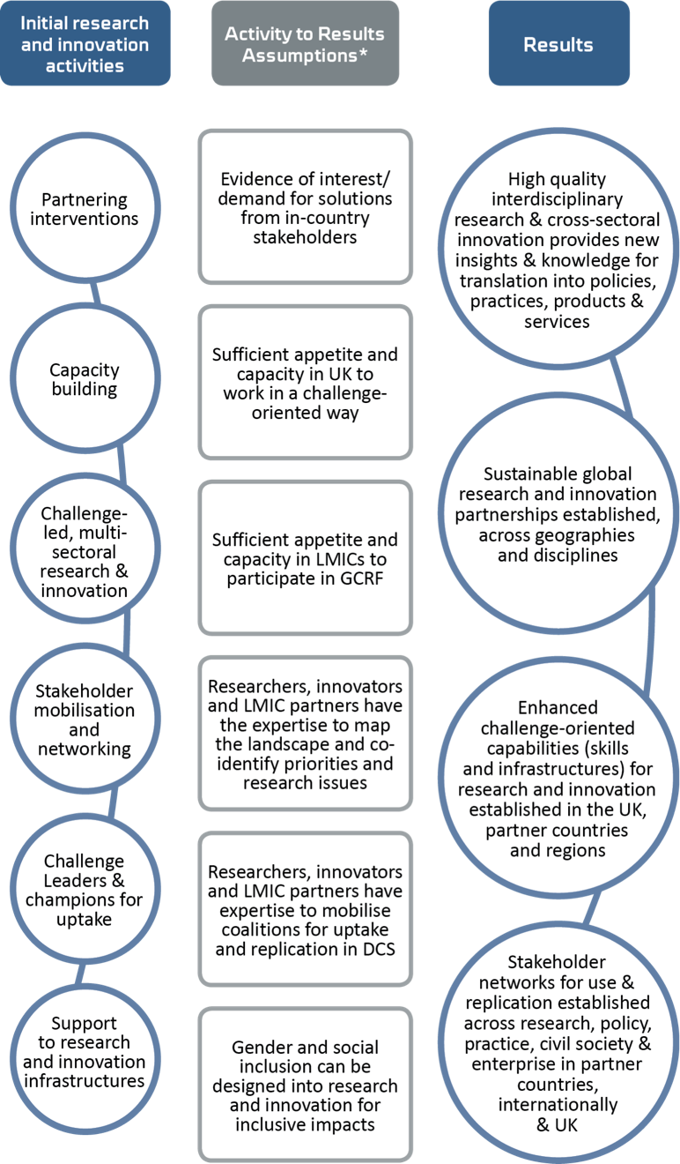

Figure 4: The GCRF ToC, showing activities to results and key assumptions on which they are based

* High-quality, relevant interdisciplinary R&I that provides new insights and problem-solving knowledge on development challenges for translation into policies, practices, products and services
* Sustainable global R&I partnerships established across disciplines and countries
* Enhanced challenge-oriented capabilities (skills and infrastructures) for R&I established in the UK, partner countries and regions
* Stakeholder networks for uptake and replication established across research, innovation, policy, practice, civil society and business.

These outputs lay the foundations for the next level of changes to emerge in the sphere of influence.

Stage 1a and 1b evidence on interventions and early results

The first stage of the evaluation focused on the extent to which the foundations for excellent, impact-oriented ODA R&I had been built during GCRF’s early years. Stage 1a modules looked at how relevance and coherence, fairness, gender, social inclusion and poverty – the foundations for development impact – have been addressed in GCRF. Stage 1b modules looked at processes and structures in the flagship investments, as well as early results and outcomes.

The ToC update in March 2022 found that these assumptions had only partially held true. The subsequent Stage 1b process evaluations of the flagship investments found further insights.

Interventions were for the most part delivered effectively, with some missed opportunities:

* Strong practices were seen around equitable partnerships and collaboration with stakeholders and potential users of the R&I outputs.
* Interdisciplinarity has been well supported and is highlighted as a key feature of GCRF, along with scale of awards.
* Capacity building has also been a strength but without high-level framing, so it has not been fully mobilised as a pathway to impact.
* Challenge Leaders as an intervention for coherence, coordination and impact had partial success, but ambiguity about the role and unclear structures for delivering on the vision constrained the potential for stronger strategic coordination across the complicated GCRF delivery architecture. The role was discontinued in 2022 and no alternative coordination structures have been put in place.

Stage 1a identified four preconditions of impact, with good evidence to suggest that these factors are enablers of impact:

* Gender, social inclusion and poverty (GESIP) prioritised in policies and implementation of programmes and awards
* Fair and equitable partnerships with Southern partners, both academic and non-academic, support relevance and positioning for uptake
* Stakeholder engagement and collaboration across sectors in LMICs support positioning research for use
* Relevance of R&I to local of development challenges is enhanced through meaningful engagement with Southern stakeholders in project design and implementation.

Stage 1a confirmed how, in GCRF’s devolved architecture, an explicit ‘challenge fund’ approach is needed, with strategic structures and processes in place at the overall fund level, implemented at the DP/programme level and built upon by awards to provide a fund-wide architecture to maintain a focus on the preconditions for development impact. These involve four aspects:

* Strategic leadership inspiring a shared vision as well as a unified understanding of development impact
* Management processes which ensure that research excellence and development impact is prioritised, including increasing Southern voices in strategy and funding processes
* Monitoring, evaluation and data management processes prioritised and cascaded down from the fund level to ensure learning is effectively captured and applied
* Value for Money (VfM) definition and standards established at the fund level and cascaded to Partner Organisations to ensure effective cross-fund learning.

Stage 1b found that the GCRF’s ambition for R&I excellence with development impact was not adequately matched with the necessary structures and processes at the DP/programme level. The evaluation identifies six key processes for ODA R&I excellence:

* Adaptive proactive programme management at the DP level, including technical support on development processes (e.g. GESIP and equitable partnerships), is critical to ensuring a programme can deliver impact
* Coherence and cohort building to draw learning across the portfolio and drive collective progress towards learning
* Contextual risk assessment and mitigation processes at the programme and the award level are critical to working in LMIC and fragile and conflict-affected states and in supporting a consistent and risk aware approach across the portfolio
* Defining and tracking capacity development is important to ensure that a systems and multilevel understanding of capacity development is implemented at the award level (going beyond supporting Early Career Researcher to supporting the broader R&I system)
* Defining and tracking VfM based on the fund-level framing and approach to ensure consistency and cross-fund learning

Monitoring, evaluation and learning (MEL) consistent with the strategy defined at the fund level is critical for adaptive management and maintaining a focus on development impact.

This evidence provides the basis for revising the intervention-level assumptions and reviewing how this affects the subsequent ToC and impact pathway.

### Updated intervention-level assumptions

Fund-wide strategies and R&I activities integrate gender, inclusion and poverty; fairness in partnerships and stakeholder collaboration in design and delivery at all levels of the fund, including programmes and awards.

Strategic R&I programme management strategies strengthen impact in portfolios through coordinating collective action on challenges in LMICs, building cross-sector linkages with stakeholders and addressing capacity needs.

Multilevel MEL supports adaptive management, mitigates contextual risks and optimises VfM.

## Spheres of direct and indirect influence

### Outputs, research-into-use interventions, innovation development strategies and intermediate outcomes

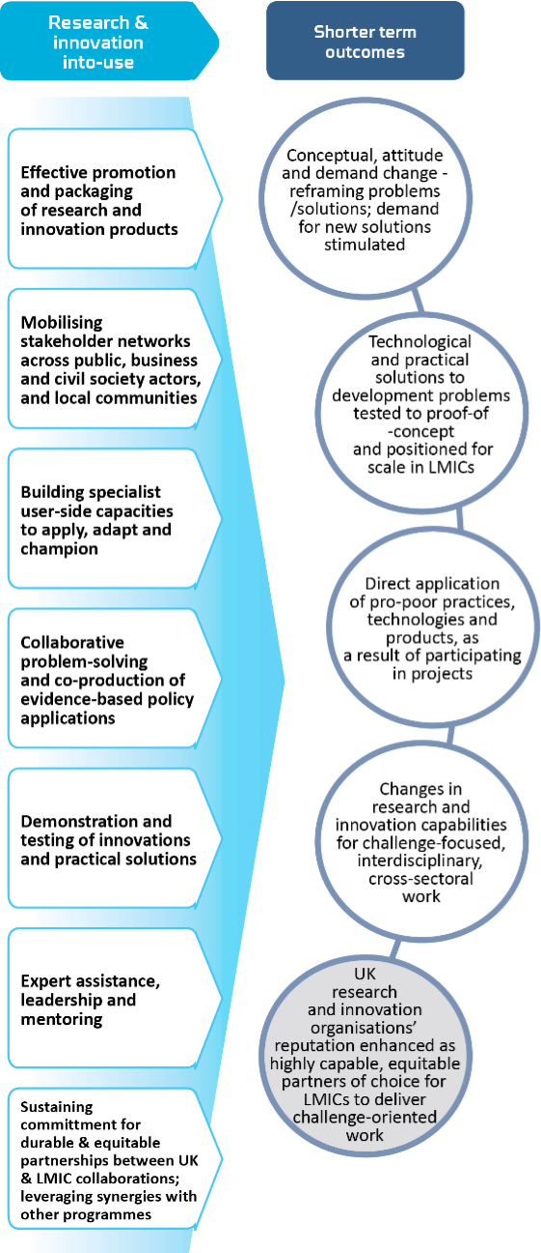The next sections remain broadly the same in content as in the original ToC, with the caveat that short, medium and long-term outcomes are still expected to emerge and through the same kinds of pathways, but with less power and duration, so that they may emerge at a more localised scale and be more scattered in their effects. The evaluation has found that the impact and delays caused by of Covid-19 and reductions in funding have curtailed the impact potential of GCRF awards. This means that the momentum for impact may not be accelerated by the later-stage investments into strategic coordination, clustering and impact activities to promote impact at scale, as originally envisioned. This means that the ToC now anticipates more scattered examples of change, perhaps at a project scales, or clusters of projects within local systems, but with potentially less of a catalytic effect at scale.

Nevertheless, GCRF still has invested an unprecedented amount – £1.5 billion – into ODA R&I, so there is still good potential for outcomes and impacts to emerge, some of which have potential to promote significant change in LMICs. At the time of writing, however, we have limited evidence on this aspect of the ToC. Stage 1b (2021–23) and Stage 2 (2023–25) of the evaluation will explore in depth what GCRF has achieved in terms of a lasting legacy in LMICs and for the UK. The ToC will be reviewed and updated again in the final stages of the evaluation, when the complete evidence is available.

The complete original narrative can be found in a separate document.[21] In the next sections, we outline what the evaluation will aim to capture on this part of the ToC in the coming phases.

The sphere of direct influence represents the stage where GCRF programmes and partnerships work intensively and collaboratively with stakeholders in LMICs to develop applications of GCRF research, testing and tailoring R&I solutions to their intended country contexts. Stakeholders include a wide range of different users of the research and technology, as distinct from research-side partners, e.g. policymakers in national governments, decision makers in local government, development practitioners in public, private and civil society organisations, entrepreneurs and business leaders, and national researchers in public and private agencies.

This process is anticipated to lead to tangible results and outcomes, mainly at project and programme scales, as the intermediate steps towards supporting more widespread and established development outcomes at later stages in the ToC.

In this sphere, GCRF programmes and projects undertake intensive ‘research-into-use’ and innovation development strategies with stakeholders to facilitate translation into new policy frameworks, new products, processes and services, as well as supporting new capabilities and infrastructures. The research-into-use and innovation development stage is conceptualised as the crucial ‘transmission belt’ between research outputs and wider development outcomes. Stage 2 of the evaluation will look in depth at these pathways and the outcomes that have been supported by GCRF projects.

## Sphere of indirect influence

### Replication, amplification and higher-level outcomes

Many factors influence the extent to which evidence and innovation products are replicated and amplified within different policy, practice and market settings. The links between intermediate outcomes and more widespread change becoming established in the sphere of indirect influence are complex, as other dynamics come into play at this level to enable or inhibit progress, and the influence that GCRF is able to exert diminishes. However, the ToC proposes that GCRF must continue to proactively engage in this wider context, especially as GCRF aims to bridge sectors and push for change across challenge areas, in order to maintain its aggregate progress towards SDG-level impact. Specific mechanisms to do this were not explicitly set out in the original ToC at this level, but coordination structures such as the Challenge Leaders were understood to potentially play a role here, as well as impact-oriented activities such as linking awards to follow-on funding or investors, or establishing links to ‘scaling actors’ such as the UN agencies or development banks.

Unfortunately, the evaluation evidence to date suggests that there are considerable risks to this stage of the ToC unfolding as anticipated. The Challenge Leaders were assessed as having limited effectiveness and the role was discontinued in 2022 with no alternative coordination structures being put in place. Similarly, there is little evidence as yet of linking and positioning activities being undertaken for clusters of awards, while mobilising networks for uptake is an area that has been most effected by ODA budget reductions in 2022.

Despite this, the evaluation does not have sufficient evidence about these processes to change the ToC at this stage, and so these dynamics remain valid, based as they are in the wider evidence and theories about pathways to impact.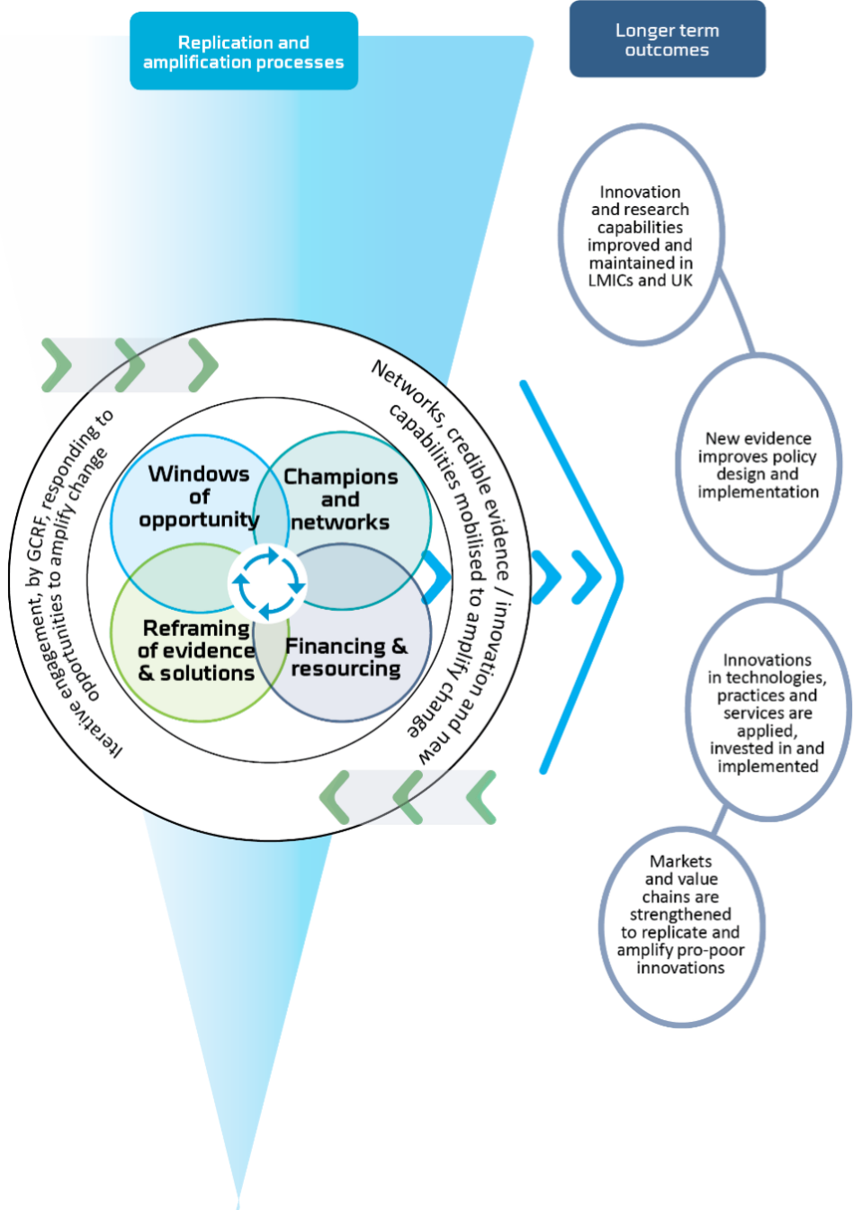 These dynamics will be explored further in the final module of the evaluation, the Research into Use case studies.

The ToC summarises these complex contextual dynamics as a set of ‘influencing conditions’ that are likely to affect replication and scaling of innovations and research products.[22] Some conditions can be influenced by GCRF, others emerge serendipitously from other factors in the context, but all need to be navigated and optimised by GCRF and its stakeholder networks to make progress towards the desired impact. These influencing conditions have been grouped into four main categories as a conceptual device to simplify the context and to assist GCRF projects and programmes to use the framework to help navigate the context and design their engagement strategies. These four interlinked categories of influencing conditions shape the opportunities for GCRF’s work to scale towards impact.

1. ‘Windows’ of opportunity. This set of conditions describes the dynamic contextual conditions within the broader institutional, political, social, economic and environmental landscape that open up (or close down) opportunities and prospects for further adoption and replication, including:

* Political economy dynamics, extent of civil and political freedoms in the country
* National development vision, goals and political/economic pathways being followed
* Institutional arrangements and political and social contestation of these pathways
* Urgency and tractability of policy problems for local stakeholders, political economy incentives to tackle these, and dynamics of policy entrepreneurship around the issues.

2. Networks and champions for replication. This set of conditions describes the dynamic configurations of individual and institutional leaders and stakeholders, their behaviours, interrelationships and mutual influence that need to be engaged to catalyse replication and amplification, including:

* Supporting and/or aligned cross-sectoral coalitions of advocates, champions and potential individual and/or institutional allies; knowledge communities; sectoral networks across research, policy, civil society and business; advocacy coalitions, civil society and alignments; local communities, community-based organisations (CBOs), governance and/or producer organisations
* Roles, links and influence of international donors, investors and international processes
* Extent of trust, knowledge exchange, attitudes and incentives among policy, practice, business and community stakeholders, their room for manoeuvre, local history and power relations.

3. Reframing of problems, evidence and solutions. This set of conditions describes the dynamic interplay between prevailing and novel narratives and framings of problems; the availability, alignment and legitimacy of evidence about problems; ‘what works’; technology, product and service innovations; and the motivations of stakeholders to engage with this – including:

* Prevailing and novel/disruptive narratives about the determinants of urgent development challenges, institutional agendas and current investments among local, national and international players
* Accessibility, diversity, accuracy and legitimacy of the available evidence and innovation base and its operational usefulness, the credibility of evidence, extent of alignment or challenge of novel insights and potential solutions with prevailing narratives, and receptiveness of stakeholders.

4. Financing and resourcing. This set of conditions describes the availability of different financing and investment instruments and diverse actors for scaling and to develop infrastructures; market and/or community demand for innovations and solutions (policy, practice and/or products); and supporting infrastructures and resources for change (e.g. technology, natural resources).

### Higher-level outcomes

If the outcome-level assumptions in Box 1 (below) hold true, then the ToC anticipates that the following higher-level outcomes will emerge at different scales and diverse settings – local, (sub) national and international. From 2022, the shifts in the funding trajectory of GCRF mean that short, medium and long-term outcomes are still expected to emerge and through the same kinds of pathways, but at a more localised scale and more scattered in their effects. The evaluation has found that the impact of Covid and reductions in funding have curtailed the impact potential of GCRF awards. This means that the momentum for impact will not be accelerated by the later-stage investments into strategic clustering and impact activities to promote impact at scale, as originally envisioned. This means that the ToC now anticipates more scattered examples of change and less of a catalytic effect at scale. Nevertheless, the evaluation still expects to be able to identify and capture change in the dimensions framed in the original ToC. These will form the foundations of GCRF’s legacy in LMICs:

1. Innovation and research capabilities (skills, systems, infrastructures) are improved and maintained in LMICs. For example:

* National and/or international investments are established to sustain connections between researchers, innovators and stakeholders in the UK and LMICs 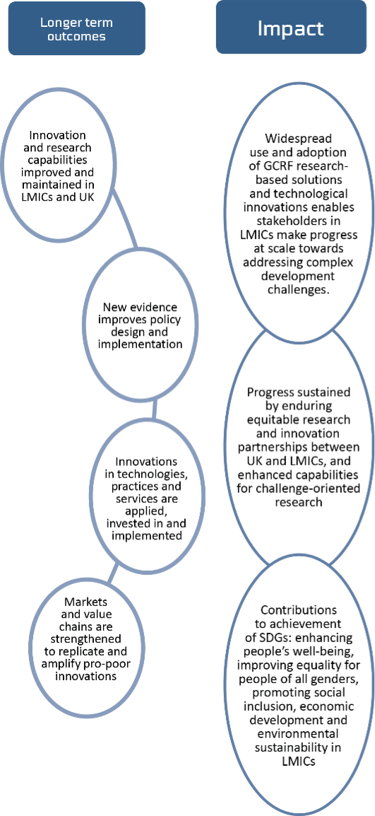
* National and/or international investment is catalysed to sustain institutional infrastructure for interdisciplinary R&I
* UK research organisations are established as highly capable, equitable partners of choice for LMICs to help deliver interdisciplinary R&I on global challenges
* Future R&I is better informed and better targeted towards high-impact, operationally useful solutions for urgent development challenges.

2. New evidence improves policy design and implementation. For example:

* Stakeholders use evidence to design and implement new and/or adapted policy content and regulatory frameworks to create new local/national/international priorities and investment areas to address urgent development problems
* Stakeholders use evidence of ‘what works’ to improve policy designs, implement more effective policy solutions with stakeholders, and improve quality standards for service delivery
* Stakeholders reform policy and decision-making processes to include more diverse stakeholders, constituents and citizens
* Civil society stakeholders and advocates use evidence in more effective advocacy and accountability campaigns that apply pressure on governments and business.

3. Innovations in technologies, practices and services are applied, invested in and implemented on a wide scale to improve people’s lives in different settings and scales. For example:

* Local communities and specific groups, such as farmers, entrepreneurs, businesses and industry adopt and diffuse new practices, technology and/or product innovations for immediate improvement (without requiring policy change)
* Stakeholders implement institutional innovations, novel management arrangements and/or technologies for a more effective and efficient response to development and humanitarian challenges
* Stakeholders apply research-based tools and/or technology innovations to support improved government and agency decision making, planning and service delivery
* Institutional innovations, such as new cross-sectoral management models, support better coordinated and more effective action on development challenges, especially in cross-border issues (e.g. in humanitarian response and ecosystems management)
* Development practitioners and humanitarian stakeholders adopt and invest in practice, technology and programme innovations that directly benefit affected populations
* Service delivery stakeholders adopt and implement new practices, technology and/or product innovations to improve efficiency and quality
* Public investment to mainstream new approaches for better management of urgent problems, e.g. in humanitarian response and/or development programmes; follow-on investment to develop and scale new technologies make processes more efficient.

4. Markets and value chains are strengthened to replicate and amplify pro-poor innovations, products, technologies and services in different sectors and industries. For example:

* Stakeholders mobilise public and/or private investment to further develop innovations
* Stakeholders advocate for standards and regulations to formalise and stimulate markets and investment into new products and services
* Local entrepreneurs, small businesses, social enterprises, intermediary and other value chain stakeholders form or grow to provide products and services to evolving value chains and to serve new markets
* Stakeholders address market-based and/or institutional barriers to technology uptake and diffusion across sectors.

Box 1: Outcome-level assumptions – updated August 2022

How and why do intermediate outcomes translate into higher-level outcomes via replication and scaling processes?

There are three critical assumptions that shape how and why project-level outcomes ripple out to a wider scale. These assumptions should be considered by DPs, researchers and innovators in their uptake strategies, and will also be explored by the evaluation.

GCRF projects and programmes are able to position their R&I for adoption and replication, due to effective foundations established at earlier stages. For example, the extent to which projects and programmes: integrate a focus on gender, inclusion and poverty; establish fair, equitable and durable partnerships; mobilise broad stakeholder networks; establish credibility and trust in the evidence and innovations produced; build the capacity of various stakeholders to apply new approaches in tackling development challenges.

Even where politics and institutions are volatile and fragile, GCRF award holders and their network partners are able to identify and respond to ‘windows of opportunity’ in the wider environment and work in a politically informed way to engage the right local stakeholders to replicate and/or scale GCRF-supported R&I outcomes, so that GCRF-supported research and innovations are taken up by development policymakers, practitioners, entrepreneurs and public/private funders and investors, and adopted into their work in a range of sectors and locations (see e.g. Booth 2018).

Momentum created by GCRF’s aggregate efforts is sustained by award holders mobilising follow-on investment so that decisive and tangible progress is made towards GCRF’s impact.

As a minimum, the ToC anticipates that GCRF’s aggregate efforts will influence lasting shifts in R&I capabilities in LMICs and the UK, with investments to sustain these made by national and international stakeholders. This will contribute to improved future research, informed by LMIC stakeholders – better informed, better targeted and therefore more impactful because of GCRF’s efforts.

August 2022 update: The original ToC proposed that this would produce a positive feedback loop that would strengthen the position of UK research organisations as highly capable, equitable partners of choice for LMIC researchers and stakeholders to deliver impactful, operationally useful development research and innovation. However, the evidence from Stage 1b finds that this positive feedback loop is at risk from the reductions in ODA budgets that impacted projects in 2022. The evaluation will explore the extent of this risk and mitigations to it from 2023 onwards.

Through these outcomes, GCRF will have contributed to equipping and enhancing the capabilities of a wide range of stakeholders in LMICs to tackle pressing development challenges in their wider settings, ultimately creating conditions for transformational change at scale.

Finally, the GCRF ToC proposes that, in the aggregate, these higher-level outcomes at local, (sub) national and international scales will accumulate and amplify to represent an important shift towards GCRF’s impact, as set out in the impact statement at the start of this ToC narrative:

‘Use and adoption of GCRF-supported research-based solutions and technological innovations in specific countries, locations and/or sectors enables stakeholders in LMICs to make progress in their settings towards addressing complex development challenges. These efforts will contribute to the achievement of the SDGs, enhancing people’s wellbeing, improving equality for people of all genders, promoting social inclusion, economic development and environmental sustainability in developing countries. These improvements will be sustained into the future by enduring equitable research and innovation partnerships between the UK and LMICs, in specific countries, contexts and sectors, supporting enhanced capabilities for challenge-oriented research and innovation in all regions.’

## Evaluation activities to capture evidence on the spheres of direct and indirect influence

The evaluation will conduct three modules at early results and outcome levels in the ToC from 2022 to 2025.These are intended to provide definitive evidence to assess the validity of the ToC by the end of the evaluation in 2025.

Research Quality Plus and Results Assessment (2022–23)

As discussed above, the ToC anticipates that GCRF’s R&I investments represent ‘excellence’ in the way development outcomes and needs are addressed. This excellence extends to their positioning for use and uptake, which involves integrating appropriate research-into-use strategies as represented in this section of the ToC, e.g. effective promotion of evidence and/or co-production of applications with policy and practice stakeholders. The Research Quality Plus (RQ+) assessment will look at this integration through a number of lenses, including assessing contextual influences such as the maturity of the research field and the governance and political dynamics in the research site. It will be accompanied by a Results Assessment, which will look for short-term outcomes in line with the ToC, e.g. tested R&I solutions and/or changes in the capabilities to conduct interdisciplinary, challenge-led work.

This module will provide evidence for updating the R&I-into-use assumptions in the ToC in order to provide the basis for subsequent modules from 2023 to 2025.

UK ODA Capacity and Benefits Study (2023–24)

This module will look at the extent to which GCRF has contributed to the national interest and to the UK’s ability to deliver cutting-edge R&I for development, as represented by the ToC short-term outcome – ‘UK R&I organisations’ reputation enhanced as highly capable, equitable partners of choice for LMICs to deliver challenge-oriented R&I’. This will gather evidence on the UK capacities that have been catalysed, the benefits that have accrued to the UK, and the attitudes of partners towards the UK as a partner.

GCRF Research-into-Use and Legacy Case Studies (2023–24)

This module will answer main evaluation question MEQ3a – ‘What results has GCRF produced, or contributed to, and what has worked in transforming outputs to outcomes?’ This module will examine the short, medium and longer-term outcomes that the ToC anticipates will emerge from GCRF’s portfolio of awards, and research-into-use processes and other pathways which enabled the results. This module will develop rich case studies of LMIC country contexts and sectors where clusters of GCRF awards working on similar themes have worked to promote change, e.g. food systems in Kenya and Uganda, transboundary ocean ecosystems management in South-East Asia. By focusing on specific contexts, this approach will enable us to explore how GCRF’s awards worked in combination with each other within local LMIC systems through a holistic investigation of GCRF’s legacy.

1. Funnel, S. and P. Rogers, 2011, ‘Purposeful Program Theory. Effective Use of Theories of Change and Logic Models, Jossey-Bass San Francisco
2. There is a rich and growing literature on how research influences societal outcomes, a selection of w hich w as review ed, for example Court and Young 2003; Nutley et al 2007; Sumner et al 2009; Grant and Wooding 2010; Donovan and Hanney 2011; New man 2014; Penfield et al 2014; Hinrichs et al, 2015; AHRC Impact report 2015- 16; EPSRC Impact Report 2016-17; DFID Research review 2016; Meagher and Martin 2017; ESPA 2018.
3. BEIS, 2017. ‘Global Challenges Research Fund (GCRF): How the Fund Works’. Available at:

   https://www.gov.uk/government/publications/global-challenges-research-fund/global-challenges-research-fund-gcrf-how-the-fund-works;

   BEIS, 2017. UK Strategy for the Global Challenges Research Fund (GCRF). Available at: https://assets.publishing.service.gov.uk/government/uploads/system/uploads/attachment_data/file/623825/global-challenges-research-fund-gcrf-strategy.pdf
4. Available at: http://www.un.org/sustainabledevelopment/sustainable-development-goals/
5. Barr, J. et al., 2018. GCRF Evaluation Foundation Stage, Final Report. Available at: <https://assets.publishing.service.gov.uk/government/uploads/system/uploads/attachment_data/file/810137/GCRF_Evaluation_Foundation_Stage_Final_Report.pdf>
6. VfM: Value for money
7. Itad, 2018. GCRF Evaluation Foundation stage: Final report. <https://www.gov.uk/government/publications/global-challenges-research-fund-gcrf-foundation-stage-evaluation>
8. BEIS, 2017. UK Strategy for the Global Challenges Research Fund. https://www.gov.uk/government/publications/global-challenges-research-fund-gcrf-stage-1a-evaluation
9. BEIS, 2017. UK Strategy for the Global Challenges Research Fund, pp 8. https://www.gov.uk/government/publications/global-challenges-research-fund-gcrf-stage-1a-evaluation
10. Stage 1a and 1b Synthesis Reports; Stage 1a GCRF Management report
11. FCDO, 2022. The UK Government’s Strategy for International Development. Available at: <https://assets.publishing.service.gov.uk/government/uploads/system/uploads/attachment_data/file/1075328/uk-governments-strategy-international-development.pdf>
12. HM Government, 2021. Global Britain in a competitive age: The Integrated Review of Security, Defence, Development and Foreign Policy. Available at: <https://assets.publishing.service.gov.uk/government/uploads/system/uploads/attachment_data/file/975077/Global_Britain_in_a_Competitive_Age-_the_Integrated_Review_of_Security__Defence__Development_and_Foreign_Policy.pdf>
13. Dickson, A., 2020. ‘Spending Review: Reducing the 0.7% aid commitment’. Available at: <https://commonslibrary.parliament.uk/spending-review-reducing-the-aid-commitment/>
14. HM Government, 2021. Global Britain in a competitive age: The Integrated Review of Security, Defence, Development and Foreign Policy. Available at: <https://assets.publishing.service.gov.uk/government/uploads/system/uploads/attachment_data/file/975077/Global_Britain_in_a_Competitive_Age-_the_Integrated_Review_of_Security__Defence__Development_and_Foreign_Policy.pdf>
15. UKRI, 2021. ‘UKRI Official Development Assistance letter 11 March 2021’. Available at: <https://www.ukri.org/our-work/ukri-oda-letter-11-march-2021/>
16. Internal BEIS communication.
17. Barr, J. et al., 2018. GCRF Evaluation Foundation Stage, Final Report. Available at: <https://assets.publishing.service.gov.uk/government/uploads/system/uploads/attachment_data/file/810137/GCRF_Evaluation_Foundation_Stage_Final_Report.pdf>
18. Vogel et al., 2022. Stage 1a: Synthesis Report of evidence on integration of relevance, fairness, gender, poverty and social inclusion in funded activities. Available at: <https://assets.publishing.service.gov.uk/government/uploads/system/uploads/attachment_data/file/1055522/gcrf-evaluation-1a-synthesis-report.pdf>
19. Vogel et al., 2022. Stage 1a: Synthesis Report of evidence on integration of relevance, fairness, gender, poverty and social inclusion in funded activities. Available at: <https://assets.publishing.service.gov.uk/government/uploads/system/uploads/attachment_data/file/1055522/gcrf-evaluation-1a-synthesis-report.pdf>
20. Vogel et al., 2022. Stage 1b: Synthesis Report of evidence on GCRF’s flagship investments. (Forthcoming)
21. Barr, J. et al., 2018. GCRF Evaluation Foundation Stage, Final Report. Available at: <https://assets.publishing.service.gov.uk/government/uploads/system/uploads/attachment_data/file/810137/GCRF_Evaluation_Foundation_Stage_Final_Report.pdf>
22. This framework is adapted from: International Development Innovation Alliance (IDIA), 2017. Insights on Scaling Innovation. Available at <https://www.idiainnovation.org/resources/scaling-innovation>. Overseas Development Institute, 2014. Tools for bridging research and policy: the RAPID Context, Evidence, Links Framework. Available at <https://cdn.odi.org/media/documents/8854.pdf>